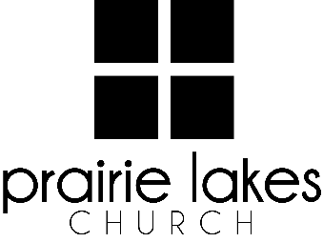

We are delighted you are considering an internship at Prairie Lakes Church! You can look forward to a challenging and rewarding year. Whether your passion is families, worship or administration, after spending a year with us, our goal is you will be more proficient with your skills, wiser as a leader and more mature as a follower of Christ.

Overview:
- You will be part of a cohort of 6-12 interns for the 2025-2026 academic year (August – May).
- You will be expected to invest a minimum of 10 hours per week during the semester.
- You will receive a stipend of $1600 per semester.

Application Deadline: February 21, 2025

Specific questions may be directed to Human Resources
internships@prairielakeschurch.org.

Guest Services Intern

This intern will report to the New Hampton Campus Pastor.

Education, Experience and Skills Requirements:
- Pursuing a degree from a college or university
- Exhibit evidence of a healthy and growing relationship with Christ
- Fully support the ministry philosophy of Prairie Lakes Church and its leadership team
- Exhibit evidence of strong relational skills
- Display evidence of strong writing skills
- Possess a strong work ethic with a demonstrated ability to initiate and finish projects

Responsibilities:
- Assist Guest Service Coordinator with weekend experience
- Oversee event coordination for First Step
- Invest in Guest Services volunteers
- Develop training resources for Guest Services volunteers
- Assist in helping guests take their first and next step
- Assist with communication-related responsibilities
- Assist in Next Steps data tracking
- Regular one-on-one meetings with New Hampton Campus Pastor

Development:
- Personalized leadership coaching & development meetings
- One-on-one mentoring
- Personalized StrengthsFinder coaching
- Exposure to all PLC campuses
- Attend retreats as scheduled

