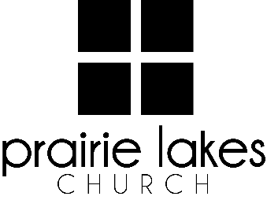

We are delighted you are considering an internship at Prairie Lakes Church! You can look forward to a challenging and rewarding year. Whether your passion is families, worship or administration, after spending a year with us, our goal is you will be more proficient with your skills, wiser as a leader and more mature as a follower of Christ.

Overview:
- You will be part of a cohort of 6-12 interns for the 2025-2026 academic year (August – May).
- You will be expected to invest a minimum of 10 hours per week during the semester.
- You will receive a stipend of $1600 per semester.

Application Deadline: February 21, 2025

Specific questions may be directed to Human Resources
internships@prairielakeschurch.org.

CS Social Media Intern

This intern will report to the Director of Marketing and Communications

Education, Experience and Skills Requirements:
- Pursuing a degree from a four-year college or university
- Exhibit evidence of a healthy and growing relationship with Christ
- Fully support the ministry philosophy of Prairie Lakes Church and its leadership team
- Possess strong communication skills
- Exhibit evidence of strong relational skills
- Possess a strong work ethic with a demonstrated ability to initiate and finish projects
- Experience in marketing or journalism
- Experience with social media, include Facebook and Instagram
- Familiarity with digital communication/marketing tools or desire to learn them.

Responsibilities:
- Monitor the Prairie Lakes online and social media presence to accurately reflect the mission and vision of Prairie Lakes Church.
- Capture photo/video content for web and social.
- Schedule posts and content for Prairie Lakes Church’s various social media platforms
- Curate successful content examples and adapt them for Prairie Lakes Church.
- Manage website events and edits.
- Contribute in developing overall platform strategies and aesthetics.
- Learn and assist PLC’s marketing strategies and campaigns.

Development:
- Personalized leadership coaching & development meetings
- One-on-one mentoring
- Personalized StrengthsFinder coaching
- Exposure to PLC campuses
- Attend retreats as scheduled

