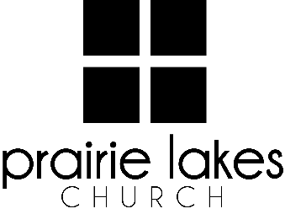
We are delighted you are considering an internship at Prairie Lakes Church! You can look forward to a challenging and rewarding year. Whether your passion is families, worship or administration, after spending a year with us, our goal is you will be more proficient with your skills, wiser as a leader and more mature as a follower of Christ.

Overview:
• You will be part of a cohort of 9-12 interns for the 2025-2026 academic year (August – May).
• You will be expected to invest a minimum of 10 hours per week during the semester.
• You will receive a stipend of $1600 per semester.

Application Deadline: February 21, 2025

Specific questions may be directed to Human Resources
internships@prairielakeschurch.org.

Creative Media Intern
Central Services

This intern will report to the Creative Media Director.

Education, Experience and Skills Requirements:
- Pursuing a degree from a four-year college or university
- Exhibit evidence of a healthy and growing relationship with Christ
- Fully support the ministry philosophy of Prairie Lakes Church and its leadership team
- Possess strong communication and IT skills
- Exhibit evidence of strong relational skills
- Possess a strong work ethic with a demonstrated ability to initiate and finish projects
- Experience with video production software a plus
- Comfortable with using video equipment
- Knowledge of Canva and Adobe Creative Cloud
- A love for engaging people through graphics and video on various content channels

Responsibilities:
- Assist with the pre-production of videos, projects, including contact the subject(s), scouting locations, and pre-interview meetings
- Record video/audio using various cameras, microphones, and audio recording equipment
- Edit video and deliver
- Travel to campuses to capture content
- Create simple graphics for events, promotion, and announcements
- Participate in Digital Strategies team meetings
- Write, direct, shoot, and edit short videos for social media markets
- Evaluate and enhance current media trends
- Assist with additional projects and tasks as needed

Development:
- Personalized leadership coaching & development meetings
- One-on-one mentoring
- Personalized StrengthsFinder coaching
- Exposure to all Prairie Lakes Church campuses
- Fall retreat

