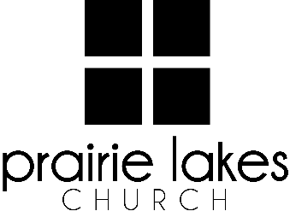

We are delighted you are considering an internship at Prairie Lakes Church! You can look forward to a challenging and rewarding year. Whether your passion is families, worship or administration, after spending a year with us, our goal is you will be more proficient with your skills, wiser as a leader and more mature as a follower of Christ.

Overview:
• You will be part of a cohort of 6-12 interns for the 2025-2026 academic year (August – May).
• You will be expected to invest a minimum of 10 hours per week during the semester.
• You will receive a stipend of $1600 per semester.

Application Deadline: February 21, 2025

Specific questions may be directed to Human Resources
internships@prairielakeschurch.org.

Worship and Production Intern

This intern will report to the Worship and Production Coordinator.

Education, Experience, and Skills Requirements:
- Pursuing a degree from a four-year college or university.
- Exhibit evidence of a healthy and growing relationship with Christ.
- Fully support the ministry philosophy of Prairie Lakes Church and its leadership team.
- Possess strong communication and IT skills.
- Exhibit evidence of strong relational skills.
- Possess a strong work ethic with a demonstrated ability to initiate and finish projects.
- A growing understanding of production elements (i.e., lighting, sound, CG and video).
- A desire to serve in the technical arts.
- Ability to work with Mac and PC equipment.
- Vocal and/or instrumental music proficiency is recommended.
- Basic understanding of music theory is recommended.

Responsibilities:
- Participate in Worship and Production brainstorming meetings.
- Participate in music or production teams at least twice a month.
- Participate in worship set build with Worship and Production Coordinator.
- Assist in Planning Center input.
- Assist in weekly ProPresenter input of songs and graphics.
- Assist Worship and Production Coordinator with All-Team planning and implementation.
- Participate in song selection and service order planning.
- Train and assist in sound board and lighting.
- Assist in volunteer coordination including the scheduling, training and recruitment of worship and production volunteers.
- Assist with W&P needs of other ministries.

Development:
- Personalized leadership coaching & development meetings
- One-on-one mentoring
- Personalized StrengthsFinder coaching
- Exposure to all PLC campuses
- Attend retreats as scheduled

