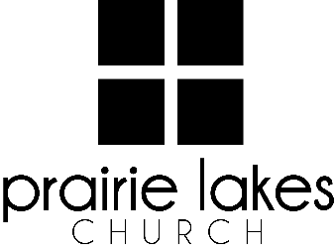
We are delighted you are considering an internship at Prairie Lakes Church! You can look forward to a challenging and rewarding year. Whether your passion is families, worship or administration, after spending a year with us, our goal is you will be more proficient with your skills, wiser as a leader and more mature as a follower of Christ.

Overview:
• You will be part of a cohort of 9-12 interns for the 2025-2026 academic year (August – May).
• You will be expected to invest a minimum of 10 hours per week during the semester.
• You will receive a stipend of $1600 per semester.

Application Deadline: February 21, 2025

Specific questions may be directed to Human Resources
internships@prairielakeschurch.org.

Human Resources Intern
Central Services

This intern will report to the Human Resources Director.

Education, Experience and Skills Requirements:
- Pursuing a degree from a four-year college or university
- Exhibit evidence of a healthy and growing relationship with Christ
- Fully support the ministry philosophy of Prairie Lakes Church and its leadership team
- Possess strong communication and IT skills
- Exhibit evidence of strong relational skills
- Possess a strong work ethic with a demonstrated ability to initiate and finish projects
- Possess a strong understanding of the Prairie Lakes Church culture
- Possess strong leadership and shepherding skills
- Previous PLC internship experience is beneficial

Responsibilities:
- Assist in planning and coordinating PLC internship events and activities
- Act as the liaison between the intern cohort and Human Resources and supervisors as needed
- Participate in the distribution of books, articles and assessments to interns throughout the year
- Assist in tracking of intern experiences and completion of checkpoints throughout the year
- Assist with various human resources needs
- Plan intern fall retreat activities and location
- Plan visits to all Prairie Lakes Church campuses

Development:
- Personalized leadership coaching & development meetings
- One-on-one mentoring
- Personalized StrengthsFinder coaching
- Exposure to all Prairie Lakes Church campuses
- Fall retreat

