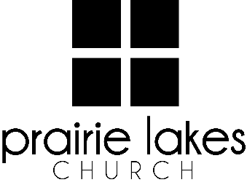

We are delighted you are considering an internship at Prairie Lakes Church! You can look forward to a challenging and rewarding year. Whether your passion is families, worship or administration, after spending a year with us, our goal is you will be more proficient with your skills, wiser as a leader and more mature as a follower of Christ.

Overview:
• You will be part of a cohort of 6-12 interns for the 2025-2026 academic year (August – May).
• You will be expected to invest a minimum of 10 hours per week during the semester.
• You will receive a stipend of $1600 per semester.

Application Deadline: February 21, 2025

Specific questions may be directed to Human Resources
internships@prairielakeschurch.org.

Early Childhood Intern

This intern will report to the Early Childhood Coordinator.

Education, Experience and Skills Requirements:
- Pursuing a degree from a four-year college or university
- Exhibit evidence of a healthy and growing relationship with Christ
- Fully support the ministry philosophy of Prairie Lakes Church and its leadership team
- Possess strong communication and IT skills
- Exhibit evidence of strong relational skills
- Possess a strong work ethic with a demonstrated ability to initiate and finish projects
- Passion for families with a heartfelt desire to grow in both knowledge and skills
- Growing understanding of children’s development

Responsibilities:
- Assist with all aspects of weekend programming of birth through pre-K at the Cedar Falls Campus such as team leading, curriculum setup, large group facilitating, leading huddles and volunteering in classrooms (average two weekends a month)
- Assist with planning, setup and execution of Child Dedication
- Participate in Children’s Ministry special events such as coaching huddles, Fall Festival, Volunteer Celebrations, etc.
- Encourage and connect with Wee Kids volunteers
- Assist with planning and implementation of Family Fusion events
- Organize classrooms to maintain a safe and clean environment for children
- Manage new initiatives, administrative tasks and projects as assigned
- Manage supplies such as snacks, diapers, wipes and art supplies

Development:
- Personalized leadership coaching & development meetings
- One-on-one mentoring
- Personalized StrengthsFinder coaching
- Exposure to all Prairie Lakes Church campuses
- Attend retreats as scheduled

